Drug Review Sentiment Analysis

# Technical Design Document

Version 1.0

RESTRICTED DISTRIBUTION

The information is standard Company Confidential , but due to its sensitivity, it has restricted distribution and viewing within iNeuron .

Document Version Control

|  |  |  |  |
| --- | --- | --- | --- |
| Date Issued | Version | Description | Author |
| 15st Aug 2020 | 1.0 | Draft | S Manish Sagar ,  Manvendra Singh Rathore |

Contributors

The content of this document has been authored with the combined input of the following group of key individuals .

|  |  |
| --- | --- |
| Name | Section Worked Upon |
| S Manish Sagar ,  Manvendra Singh Rathore | Initial Draft |

Document Classification

|  |  |
| --- | --- |
| Classification | Company Confidential |
| Definition | Information is Group confidential and needs to be protected |
| Context | Where the loss of information confidentiality would result in significant harm to the interests of the organisation, financial loss, embarrassment or loss of information |

# 1). Introduction

The goal here is to build an end to end automated Machine Learning solution where the user will only give the text review on drugs , and the result will be the best performing hyper tuned Machine Learning model. The user will also get privileges to choose the option for bulk predictions .

**This project shall be delivered in two phases :**

**Phase 1:** EDA ,Model Building andBackend work of our app .

**Phase2**: Integration of UI to all the functionalities.

The technical design document gives a design blueprint of the Review Sentiment Analysis project . This document communicates the technical details of the solution proposed .

In addition, this document also captures the different workflows involved to build the solution .

Once agreed as the basis for the building of the project, the flowchart and assumptions will be used as a platform from which the solution will be designed.

**Note: All the code will be written in python version 3.7 ..**

CHALLENGES **:**

To predict the sentiment of the text based in drug reviews .

 High level objectives:

The high-level objectives are :

1. Enable reading/loading of data and converting into pandas dataframe .
2. Perform statistical analytics of the data .
3. Perform graphical analysis for the data .
4. Perform data cleaning operation with Natural Language Processing and making new processed data .
5. After data cleaning showcase the graphical analysis once again for comparison .
6. Choose the appropriate ML model for training .
7. Create a list of top 4 models and show multiple metrics for them .
8. Modular Coding .
9. Creating Flask app and UI .
10. Dockerizing the model .
11. AWS Cloud Deployment .

## 2). Features (Attributes) :

1.drugName (categorical) : name of drug  
2. condition (categorical) : name of condition  
3. review (text) : patient review  
4. rating (numerical): 10 star patient rating  
5. date (date): date of review entry  
6. usefulCount (numerical): number of users who found review useful .

**3). Workflow Overall**

## 🡪 Application Flow



4). IMPORTANT PYTHON LIBRARIES USED IN THE PROJECT:

**1) FOR DATA WRANGLING:**

* NUMPY
* PANDAS

**2) FOR DATA VISUALIZATION:**

* SEABORN
* MATPLOTLIB

**3) EDA:**

* SCIPY
* STATSMODELS

**4) NLP**

* **VADER SENTIMENT**
* **WORD TOKENIZATION**
* **TDIDF VECTORIZOR**

**5) MODEL BUILDING:**

* LINEAR SVM
* SKLEARN

**5) API DEVELOPMENT:**

* FLASK
* REQUESTS

# 5). Workflow Data Ingestion and File Conversion :

## Technical solution design

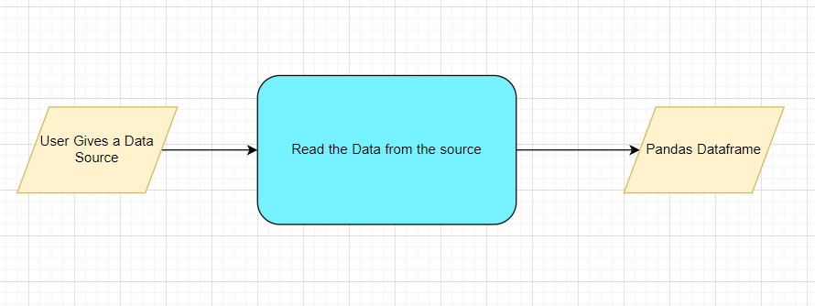

## Method Definitions 🡪

This method will be used to read data from a csv file .

# 6). Data Transformeration( Pre-processing steps)

Null value handling

Columns to datetime

Normalisation

NLP tokenization

Feature Selection

## Technical solution design :

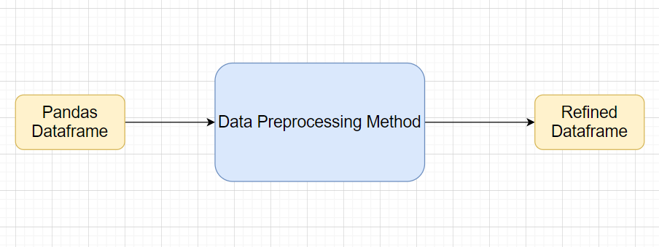

**7). Graph Based EDA**

Create the following graphs :

Count plots

Piecharts for categories

Barplots

Word maps

**We are going to use matplotlib and seaborn for all the graphs .**

## Technical solution design :

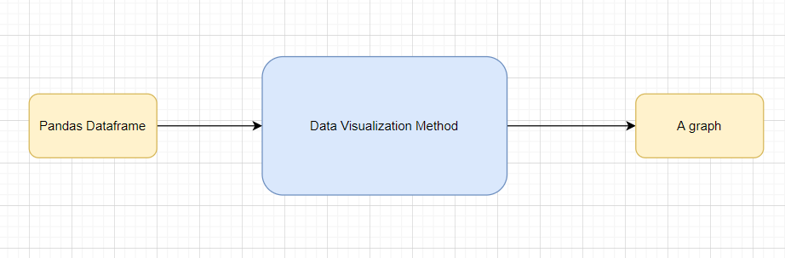

## 

# 8). ML Model Selection

Models—LinearSVC , MultinomialNB , LogisticRegression

Model Selection criteria

## 

## Technical solution design --



# 9). Model Optimization

**Note:** The data should have been divided into train and validation set before this .

Methods for optimization all kinds of models.

Model selection criteria:

Logistic Regression

Random Forest

LinearSVC

MultinomialNB

Model selection criteria:

Accuracy score

**Techniques :**

VaderSentiment

NLP

# 10). Testing Modules

Use test data to have tests run on the four best models

Give the test report

1. Accuracy
2. Precision
3. Recall
4. F1 Score

Save the best model after validation is completed .

## 

## Technical solution design

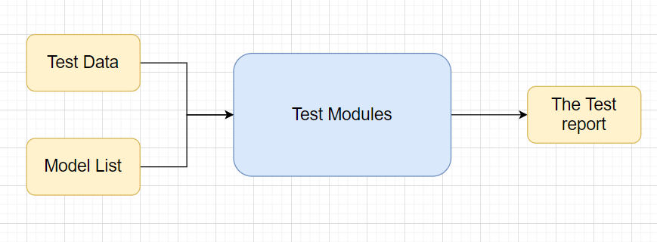

# Prediction Pipeline

Use the existing data read modules .

Use the existing pre-processing module .

Load the model into memory .

Do predictions .

**================================================================**

**Phase 2:**

UI for predictions

Show prediction results .

**1). Deployment Stratergy**

*) Dockerizing the model .

*) Deploying the model in AWS cloud services .

**Steps ->**

**1). Create a new instance in EC2 in aws and create a new pem file through create new key option .**

**2). Open security groups and create a new security group and name it.**

**3). Make following changes in inbound rule –**

**Type – All Traffic , Destination – Custom .**



**4). Open network interfaces , select the instance you made in first step , and change the security groups to New security group here .**

**5). Now configure putty gen and create new ppk file using above pem file .**

**6). Open Winscp and load the required files in your vm’s(Ubuntu) directory .**

**7). Open Putty and use the link of Instance created in first step and provide the same ppk file here and launch your vm .**

**8). Pip install reeuirements.txt and launch application.py .**

**9). Open browser and copy the connect link of instance and mention port number after it (i.e. - link:8080 )**



**10). The app will be hence deployed .**

**Refrence link :- In Later part of document .**

**2). Dockerization (Locally) :-**

* Download Docker Desktop or Docker toolbox (according to your system configurations ).
* **For Docker desktop** – Run Docker desktop and open WindowsPowershell as your CLI .
* **For Docker Toolbox** – Open Docker toolbox , you will get your CLI to write docker commands .
* **Create a dockerfile in your working directory (can use refrence link referred in Refrence Section for help )** .
* **Use commands** –
* **$docker build** -t app_name . (for building docker image ) 
* **$docker run** –p 8080:5000 app_name:latest (for running the app , here :- **8080** – is the port number on which you want to deploy your app . **5000** – is the port number which you have specified in your application.py and docker file . **app_name** – is the name of your docker image . **latest**  – is your tag_name of your docker image . )



# 3). Monitoring :

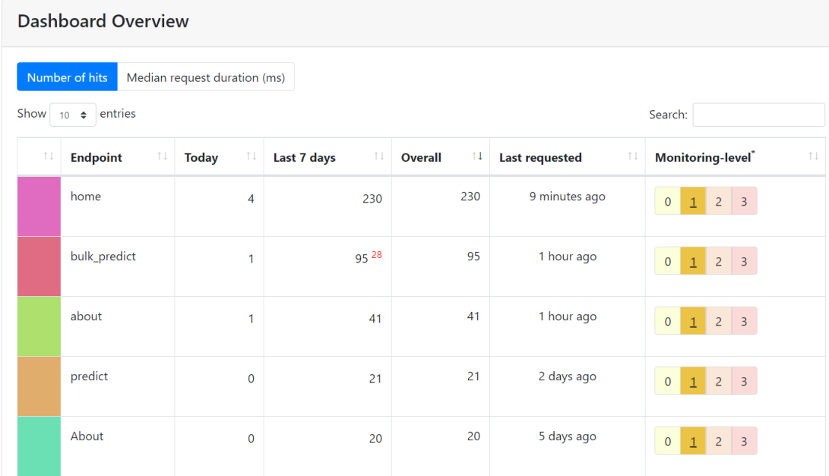

No. Of predictions

No. of predictions (per day, per hour, per week etc.)

No. of hits

Training data size (number of rows)

Time spent in training

Failures

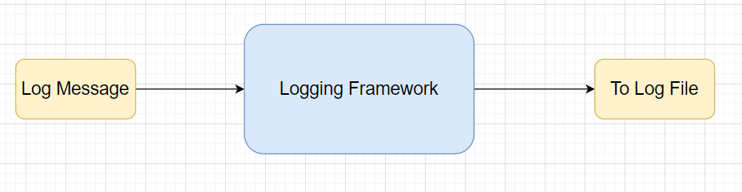

**4). Logging :**

Providing log file of the whole model in order to ->

*) Monitoring the whole walkthrough of our model working .

*) Check the cause behind any error if occurred

.



## 

**5) Final UI :-**



* While Using Click On **About Button** on the top left corner

for info .

**========================================================**

**Difficulties Faced :**

* In EDA , in choosing important features .
* In Bulk Prediction Part in UI .
* In Deployment .
* In Dockerization .

**Things Learned :**

* A bit of NLP
* Flask and UI
* Deployment
* Proper aproch to complete an end to end ML Model .

**Refrence point :-**

* **Deployment –**

<https://www.youtube.com/watch?v=oOqqwYI60FI&t=1045s>

* **Docker -** <https://www.youtube.com/watch?v=hTacGMfL8lc&list=PLZoTAELRMXVNKtpy0U_Mx9N26w8n0hIbs>
* **Flask** - <https://flask.palletsprojects.com/en/1.1.x/>

**# Hardware Requirements**

## Requirements for model training

The minimum configuration should be:

4 GB RAM

2 GB of Hard Disk Space

Intel Core i5 Processor

## Requirements for model testing

The minimum configuration should be:

4 GB RAM

2 GB of Hard Disk Space

Intel Core i5 Processor .